Utah Department of Environmental Quality
Division of Drinking Water

GUIDANCE FOR HAULING DRINKING WATER

Original Version: June 29, 1979
First Revision: February 18, 1999
Latest Revision: September 4, 2014

This document, provided by the Utah Division of Drinking Water, contains information and requirements for hauling drinking water in a manner that protects public health. It has a total of 4 sections and 4 appendices:

- Introduction
- Obtaining DDW Approval to Haul Water
- Guidance for Hauling Water
- Appendix A. Table 1 — Chlorinating with 5 % Sodium Hypochlorite (Household Bleach)
- Appendix B. Figure 1 — Suggested Methods of Providing Air Gap
- Appendix C. Checklist for Hauling Water (in Excel format)
- Appendix D. Chlorine Dose Calculator (in Excel format) — Available at the Division’s website

- Introduction

Hauling is not usually an acceptable method of water distribution, but it is sometimes necessary in emergencies and other unusual circumstances. The Division encourages water systems to develop contingency plans for acquisition and use of approved water hauling vehicles to plan for an emergency in advance. An emergency response plan may include an inventory of bottled water manufacturers, milk haulers, fire departments, street maintenance departments, construction companies, the National Guard, and farms that are potential resources for hauling water. The Division will work with public water systems in reviewing and pre-approving emergency water-hauling vessels and equipment.

If a water system provides drinking water to 25 or more people and is in operation at least 60 days of the year, it is a Public Water System (PWS), and is regulated by state laws. Utah Administrative Code R309-550-10 specifically requires that water hauling must be reviewed and approved by the Director of the Division. Water hauling is not an acceptable permanent method for drinking water distribution in Community PWS. The Director may allow water hauling for Non-Community PWS by special approval. In addition to the Director’s approval, water systems should also consult with local health departments about local restrictions or requirements on water hauling.

- Obtaining DDW Approval to Haul Water

Plans to haul water by Public Water Systems must be approved by the Division. The Division may approve the plans, but only if under the following conditions:

- the water hauling plan is not for a permanent method of distributing drinking water in a Community PWS; and,
- consumers cannot otherwise be supplied with good quality drinking water; or,
- the nature of the development, or ground conditions, are such that the placement of a pipe distribution system is not justified.

A water system must provide detailed information with its request for water-hauling approval to the Director for review. The supporting information shall identify the following:

- Public Water System (PWS) Name and PWS Number;
- reasons and justifications for hauling water;
- source of the hauled water (e.g., source name and ID, water supplier, address, location, description, etc.);
- evidence of permission or rights to take the water from the source (or water supplier);
- description of type of vessels, vehicles, and equipment for transporting the water;
- frequency and estimated quantity of hauling water;
- hauling water procedures;
- type of disinfectant that will be used and whether it meets ANSI/NSF 60 standard;
- frequency and method of cleaning or disinfecting the vessel and equipment that may be in contact with hauled water;
- frequency and method of monitoring chlorine residual of the hauled water;
- frequency of proposed bacteriological sampling of the hauled water (e.g., initial sampling followed by weekly sampling, etc.); and,
- local authority contact that has approved of or concurred with the water hauling request (e.g., the contact person in the local health department).

- Guidance for Hauling Water

Source of Hauled Water

- Draw water from a source that is rated “Approved” by the Division.
- Obtain supporting documentation showing permission or concurrence by the owner of the “approved source” to provide hauled water.

Equipment

- The surfaces that may be in contact with drinking water, e.g., tank walls/coatings, gaskets, hoses, fittings, pumps, etc., shall meet the ANSI/NSF 61 standards.
- The equipment, including pumps, must not have been previously used to transport items other than drinking water or items for human consumption.
- Tanks must be constructed to permit complete draining.
- The tank vent should be downturned and be covered with a No.14 mesh or finer stainless steel screen.
- The hauling equipment shall be designed to minimize the entry of foreign material during loading, unloading, and transport. Caps and keeper chains shall be provided for all outlets and hose ends. Tank access ports shall prevent contamination and be kept locked when not open.
- Maintain an adequate air gap between the end of the loading hose and the overflow of the water tank to protect the water source from contamination. This air gap must be at least three times the inside diameter of the loading hose. If the opening of the loading hose is not close to a wall (nearest edge of opening farther than four times hose diameter) the air gap can be reduced to two times the inside diameter of the loading hose. A suggested means of maintaining the air gap is shown in Figure 1.
- Any pump used for transferring the hauled water must:
  - either be permanently connected to the tank or have only been previously used to transport drinking water or items for human consumption; and
  - lubricated with mineral or food-grade oil meeting Food and Drug Administration (FDA) or National Science Foundation (NSF) standards for human consumption and pump manufacturer’s specifications.

Clean and Disinfect Equipment and Vessel

- Thoroughly clean all accessible water-contact surfaces the first time the equipment is used for hauling water, after extended periods of non-use, and periodically thereafter. Scrub, brush, or steam clean as appropriate. Detergents may be used, but no solvents or toxic cleaners are permitted. After cleaning, the equipment should be thoroughly flushed and drained.
- Use a disinfectant that meets the ANSI/NSF 60 standard.
- Disinfect all water-contact surfaces by one of the following methods. (See instructions for chlorine dosing in Table 1.)
  - Swabbing or spraying. Prepare 200 parts per million (ppm) or mg/l chlorine solution per instructions in Table 1. Swab or spray all water contact surfaces with solution. Reapply solution as necessary to keep surfaces wet for 30 minutes minimum.
  - Chlorination of full tank. Add enough chlorine to the tank to achieve a concentration of at least 50 ppm when the tank and accessories are filled with water. Instructions for preparing chlorine solutions are shown in Table 1. Fill the tank and accessories with water. Let solution stand for at least 24 hours. If enough chlorine is added for a 200 ppm solution, let the solution stand for at least 30 minutes.
- After disinfection, drain the chlorine solution and thoroughly rinse the equipment. (Contact Division of Water Quality for permit if discharging chlorinated water that may affect surface water quality or aquatic life.)
- Keep the system clean and avoid contamination during operation. Protect inlets, outlets, and hose ends by capping when not in use. Avoid contamination when loading and distributing water. Hose ends shall not contact the ground.

Load and Unload Hauled Water

- Avoid contaminating the water source. Maintain an air gap as discussed in Step 6 under the sub-heading of Equipment. Take extra caution to minimize contamination through the air gap when conditions are windy or dusty.
- Close the discharge and add enough chlorine to make a 1 ppm solution when the water tank is filled. See instructions for making chlorine solutions in Table 1.
- Fill the tank with water.
- Measure residual chlorine when unloading. If residual free chlorine is less than 1 ppm, repeat Step 2. (If unable to test free chlorine residual, double the chlorine called for in Step 2.)
- Verify a minimum chlorine residual of 1 ppm after a contact time of at least 30 minutes.

Distribute Water
- Avoid contaminating the water-hauling equipment when transporting and making deliveries. Keep discharge and loading connections clean and protected.
- Water systems are advised to periodically collect water samples for bacteriologic analysis throughout the period of hauling water. Specifically, collect an initial sampling from the first load of hauled water, after extended periods of disuse, and routinely, such as weekly or monthly.
- In some cases, the hauled water will be supplied to the water users that have individual water cisterns or long service lines. These cisterns and service water lines are not maintained by the water systems, are specifically prohibited by State regulations, and are susceptible to contamination. For this type of water distribution, special cautions should be taken in maintaining disinfectant residual and taking bacteriological samples.

Appendix A.

Table 1. Chlorinating with 5 % Sodium Hypochlorite (Household Bleach)

Target Chlorine Level | 1 ppm | 10 ppm | 50 ppm | 200 ppm
Gallons of Water Treated | Volume of 5% Sodium Hypochlorite Solution
15  30  62  125  250  500  1000  1500  5000 | 1/4 teaspoon  1/2 teaspoon  1 teaspoon  2 teaspoons  1.25 tablespoons  2.5 tablespoons  1/3 cup  1/2 cup  1.5 cups | 2.25 teaspoons  4.5 teaspoons  3 tablespoons  6 tablespoons  3/4 cup  1.66 cups  3.25 cups  4.75 cups  1 gallon | 1/4 cup  1/2 cup  1 cup  2 cups  4 cups  1/2 gallon  1 gallon  1.5 gallons  5 gallons | 1 cup  2 cups  4 cups  1/2 gallon  1 gallon  2 gallons  4 gallons  6 gallons  20 gallons

Calculations in the table above do not account for possible chlorine demand in the receiving water nor the degradation of chlorine solution strength. Some substances in the water may consume part of the chlorine. Chlorine solution may lose its original strength due to time, heat, or exposure to UV light. Take a chlorine residual measurement after 30 minutes. If the residual is below your target residual, calculate the amount needed to replace what was consumed. Take a chlorine residual measurement after another 30 minutes. Repeat as needed.
Appendix B.

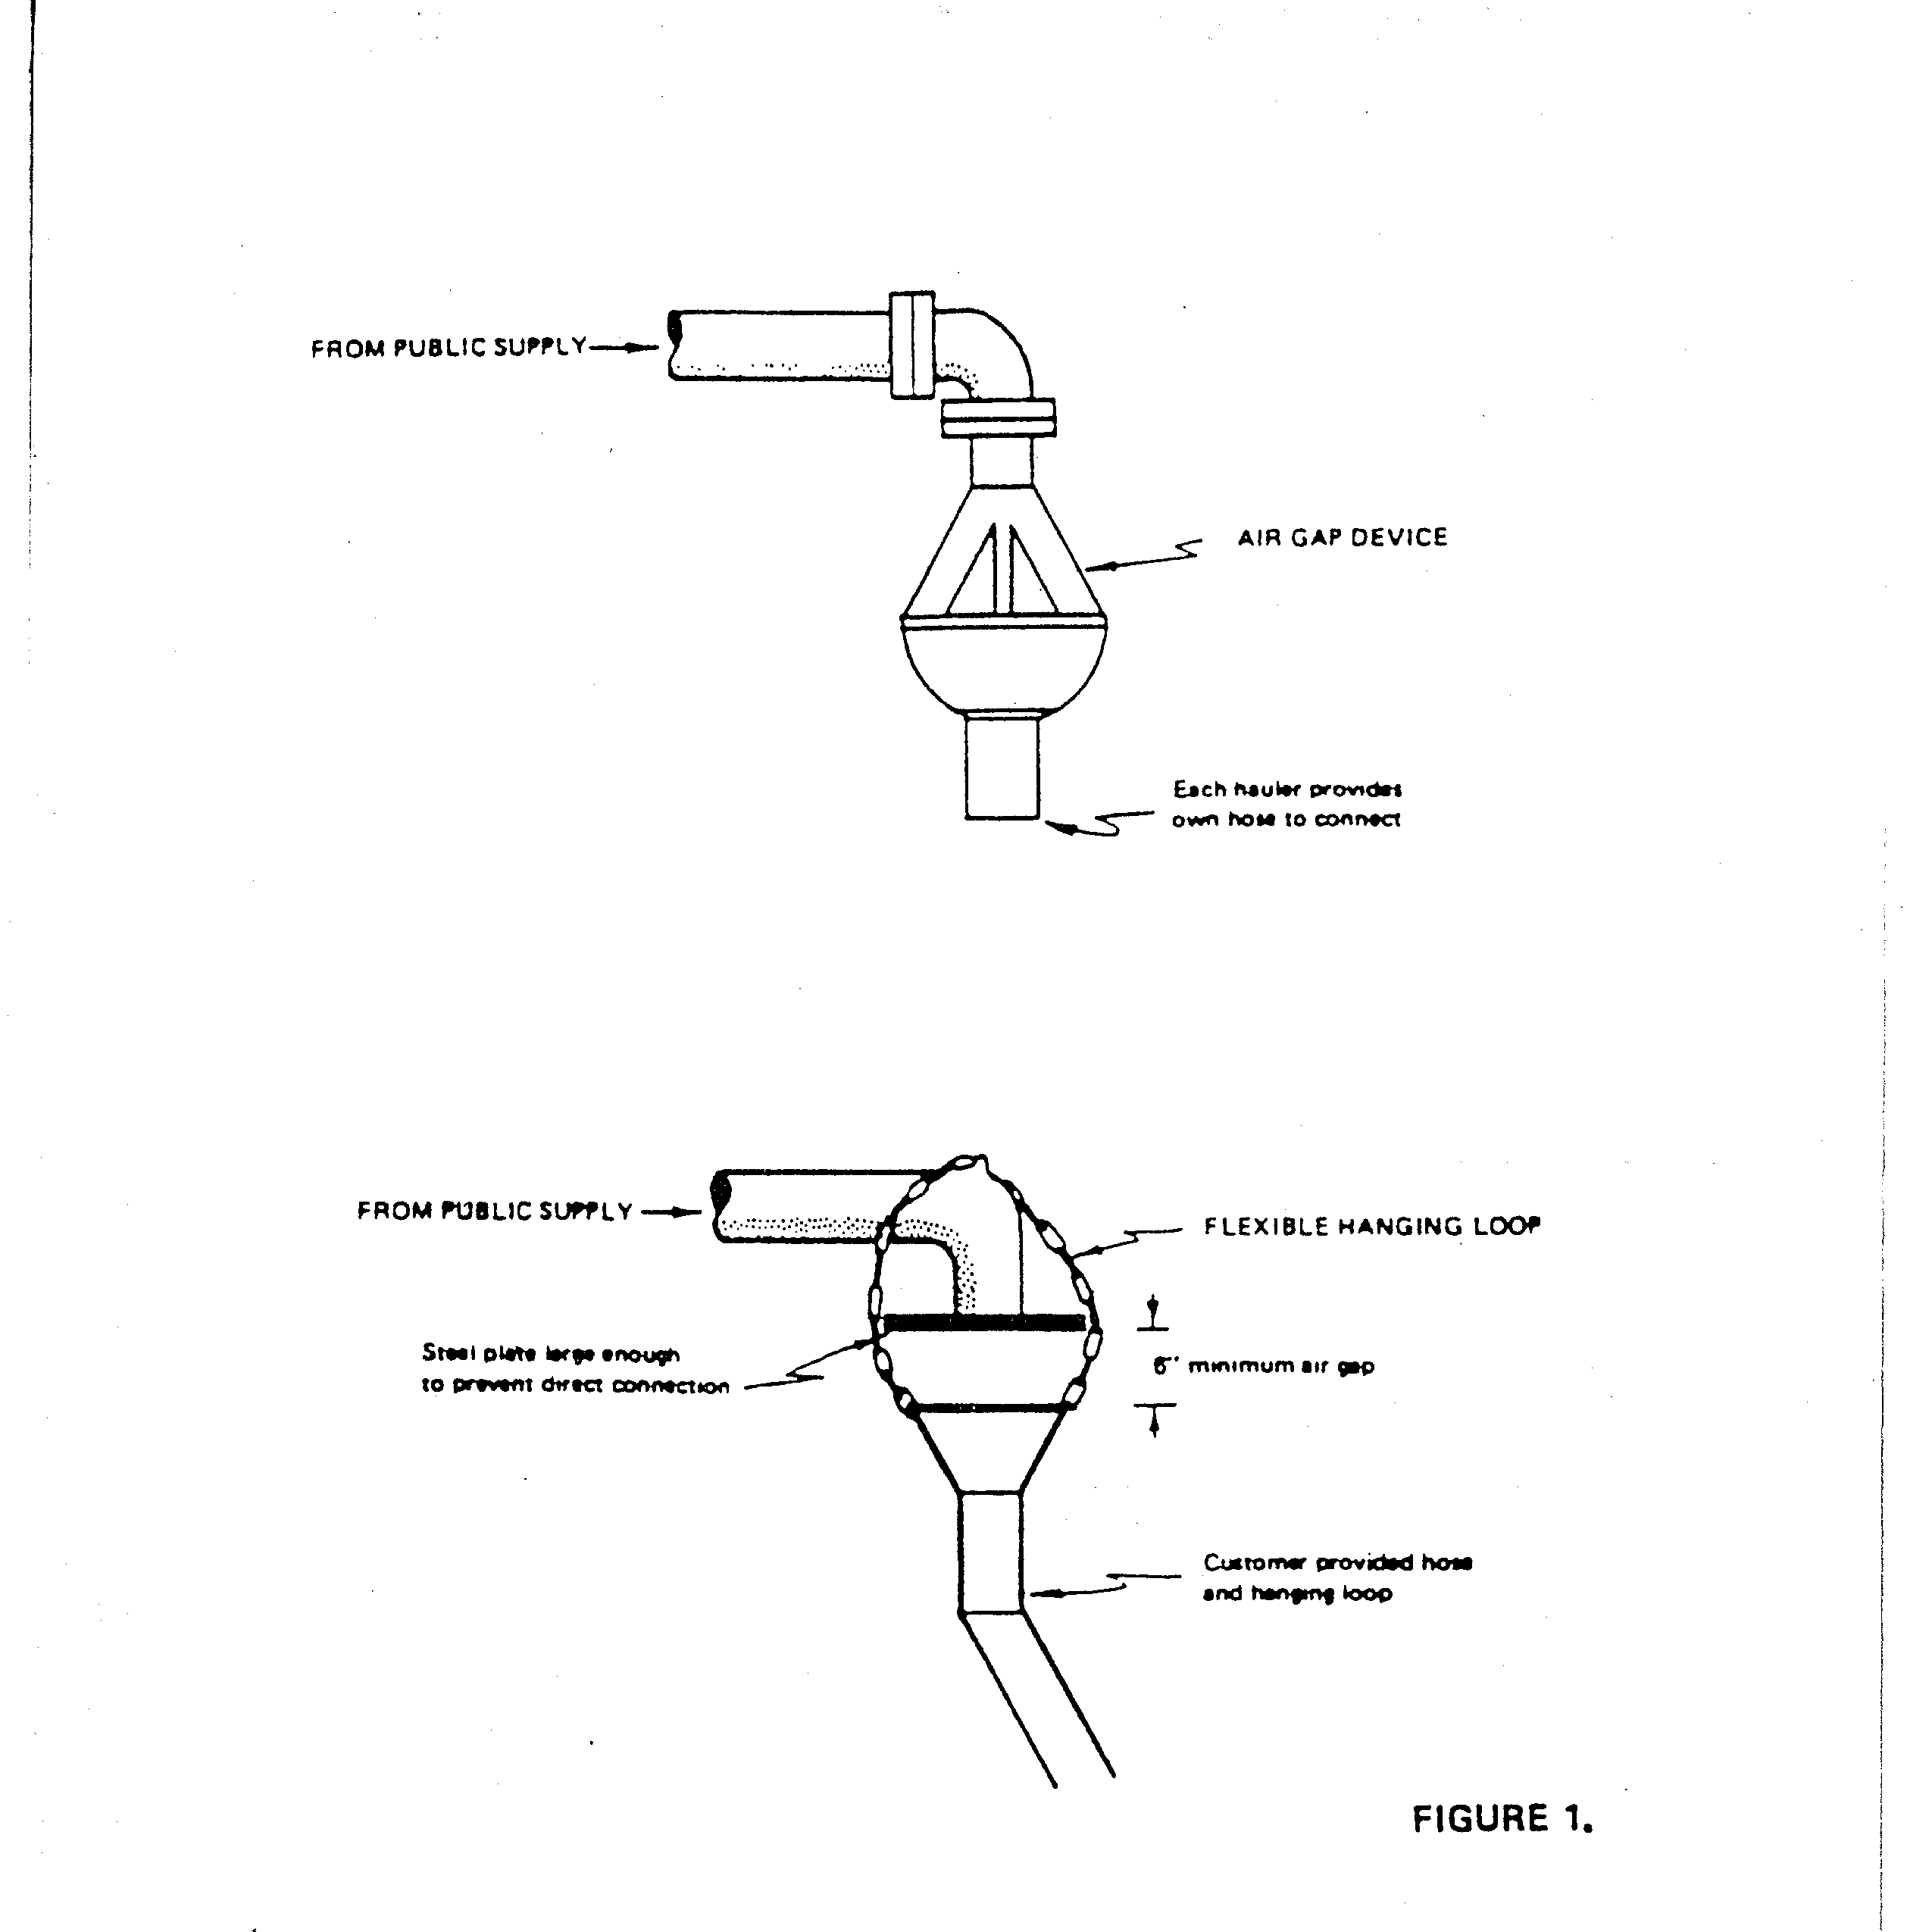

Figure 1. Suggested Methods of Providing Air Gap.
Reproduced From 1997 Edition of “Recommended Standards for Water Works”

